 |  | INVESTIGATION REPORT - Draft
PK-WHR  RH Wing Fuel Leak |  |  | No. | : | 006/SS/IR/VI/2021
 |  |  | Date | : | 18 June 2021
 |  |  | A/C Type /Reg. | : | ATR72-600/PK-WHR
 |  |  | Location | : | Station BXB
 |  |  | Distribution | : | LM, Quality, MCC, BAT Training, SSQ 121 IW
V | Incident / Accident | V | Maintenance Malfunction / Defect |  |  |  |  | Other
DETAILS
- SYNOPSIS:

On Friday, 04 June 2020, 23:50 UTC, Aircraft PK-WHR with flight number IW-3544 landing at station Babo (BXB) from Ambon (AMQ). During performing walk around check, engineer found fuel leak from RH under wing. Engineer continued to perform detail check on the RH upper wing to find out the source of the fuel leak. And it was identified that the source of the fuel leak came from one screw on the fuel tank panel probe #1 (16 QT) which improper tightened (it was repaired with a layer of PRC sealant). The defect of fuel leak has documented at the AFML W 637631.

Previously, on 01 June 2021, a trouble shooting of DMI RH fuel unbalance was conducted by performing capacitance check of RH wing tank fuel probe #1, refer to MP ATR-A-28-42-70-01001-340A-A.

During performing capacitance check when removal of the RH wing tank fuel probe #1(16 QT) process, it was found one screw was hard to open and it was unable to retighten properly as well during installation the fuel probe #1 (16 QT). Therefore, the engineer repaired it with a layer of PRC sealant to the screw in order to make the screw keep on tighten.

However, the repair of the screw with a layer of PRC sealant to prevent fuel leak during installation the fuel probe #1 (16 QT) on 01 June 2021 did not last long due to in fact that fuel leaking out from the fuel tank panel probe #1 (16 QT) was noticed during performing transit check at station Babo on 04 June 2021.

BAT safety department raised the investigation on this case to find out the root cause of this case with intended to prevent the same occurrence from happening in the future and this is provided to promote safety culture in the BAT organization and not to blame.

- Aircraft Data Per 04 June 2021 (The occurrence fuel leak from the fuel tank panel probe #1)

Description | ATR 72-600
Aircraft Registration | PK-WHR
Aircraft Line Number | 1298
Aircraft Flight Cycles | 10330 Cycles
Aircraft Flight Hours | 9295 Hours ; 42 Minutes

- Other Information
This investigation takes several data sources as the reference as follows:
- Chronology report engineer in charge,
- AFML report,
- Functional test of the fuel quantity-probe system task: ATR-A-28-42-70-01001-340A-A,
- Removal of the fuel probe task: ATR-A-28-42-70-00001-520A-A,
- Installation of the fuel probe task: ATR-A-28-42-70-00001-720A-A,
- TRAX data defect report,
- TRAX data flight cycles & hours report,
- AOG report & serviceable report,
- Quality report 026‐QLM‐VI‐2021.
- Interview with engineer in charge

- Data of Evidences

- Figures Aircraft PK-WHR - MSN: 1298
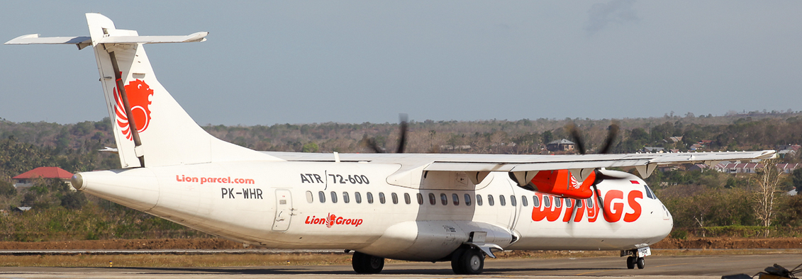

- RH Fuel Leak Evidence

RH Wing fuel probe #1 (16 QT) One screw layered by sealant Damaged fastener
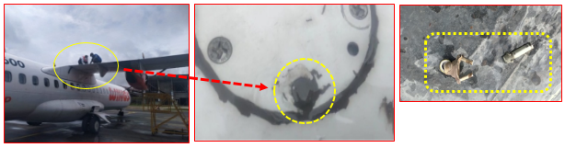

- AFML Data :
- Number W 637631 - Post the Occurrence IW-3544 : AMQ-BXB
Station BXB
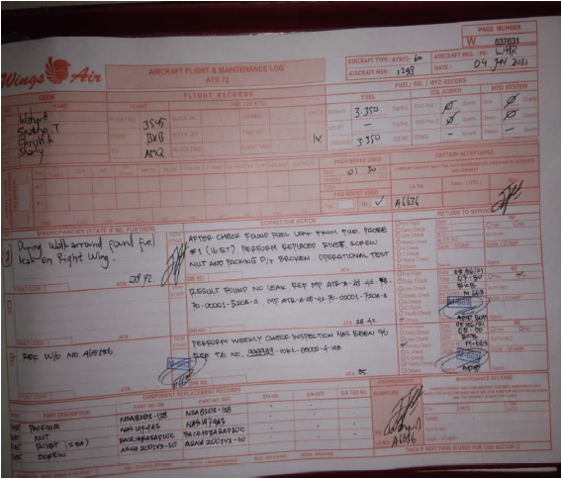

Note :

Note :
- During walkaround found fuel leak on RH Wing

- Damage Analysis
- Aircraft Condition:
- Fuel leak comes out from RH Wing probe #1 (16QT)
- Aircraft was declared on ground due to waiting spare fastener (screw, nut, packing).

- Personil Condition:
- NIL Injure.

- Maintenance Chronology

a. | 22 May 2021 | : | At station AMQ,  Issued DMI 28-42-01 Fuel Unbalance RH Tank drop until 150 kg  Waiting Spare Fuel Probe & O-ring  MEL Category C
b. | 01 June 2021 | : | At station AMQ,  Performed functional test of the fuel quantity probe system, During removal of the RH wing tank fuel probe #1(16 QT) process, it was found one screw was hard to open, and it was found unable to be retightened properly during installation, the fuel probe #1 (16 QT)
c. | 04 June 2021 | : | At station BXB,  During performed walk around check post flight IW-3544: AMQ (Ambon)-BXB (Babo), found fuel leak comes from fuel probe#1 (16 QT), which is one screw repaired by sealant PRC

- Evidences Report Data

Evidence of report data to support this investigation report are attached.

- Corrective Action

Maintenance action post the occurrence of aircraft stop and block runway was performed as follows:
- Identified that the RH wing fuel leak was comes out from RH fuel probe #1 (16 QT).
- Performed Inspection check on the RH fuel probe #1 (16 QT), one screw improper tighten
- Performed replacement of the screw, anchor nut and packing fuel probe #1 panel due to broken
- Performed operational Test Result found no leak, Ref MP ATR‐28‐42‐70‐00001‐520A‐A, MP ATR‐A‐28‐42‐70‐00001‐720A‐A
- Aircraft Declared serviceable on 05 June 2021, at 07:30 UTC.

- Safety Hazard
Risk Assessment

Risk probability | 3 Remote | Unlikely, but possible to occur (has occurred rarely)
Risk Severity | C | Major
Risk Index | 3C | Risk control / mitigation requires management decision.

- Analysis
BAT Safety Department got some finding during investigation (by methode of collecting related data and conducting interviewed with the related personnel) as follows:

- Fuel unbalance (RH tank drop until 150 kg)
On 22 May 2021, during flight IW-2502 route FKQ-AMQ, Aircraft PK-WHR experienced problem of while cruise and descend sometimes fuel unbalance on EWD (Engine Warning Display) RH fuel tank less than LH until 150 kg, following fuel mismatch and LO LVL but system check all normal, ref to AFML W 624293.
The maintenance action has been performed until finally finding failure at the RH fuel probe #3 (152 QT) which caused problem fuel unbalance above.
Due to the spare fuel probe #3 (152 QT) was not available at the station AMQ at that time, therefore the problem was inserted to DMI (Deferred Maintenance Item) No. 007387: Fuel Unbalance (RH tank drop until 150 kg) refer to MEL (Minimum Equipment List) 28-42-01 category: C, since that day.
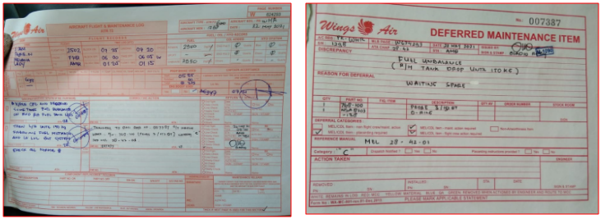
Below is the evident of problem and insertion to DMI.

AFML W 624293
AFML 007387

- Functional Test of the Fuel Quantity-Probe System
On 01 June 2021, the engineer in charge has received the instruction from MCC through What App message to continue trouble shooting DMI No. 007387: Fuel Unbalance (RH tank drop until 150 kg). Followed up this instruction, the engineer in charge LM AMQ performed functional test of the fuel quantity probe system on the RH Wing ref task MP ATR-A-28-42-70-01001-340A-A.
The all six fuel probes: #1 (16Q), #2 (18QT), #3 (152QT), #4 (20QT), #5 (22QT), and #6 (28QT) on the RH wing tank were checked to ensure the capacitance value of each fuel probe was in limit.
During capacitance test, it was found that one of six fuel problem, that is fuel probe #3 (152QT) was under limit.

- Removal of The RH Wing Fuel Probes.
Removal of the fuel probe was performed with reference to the task ATR-A-28-42-70-00001-520A-A accordingly. Based on the formal chronological report, the engineer admitted that during the fuel probe removal process, it was found that two of six screws on the fuel probe #1 were hard to be removed. This information is also conveyed during the interview.
- Installation of The RH Wing Fuel Probes.
Refer Task: ATR-A-28-42-70-00001-720A-A, the installation of RH wing fuel probes were conducted. All fuel probe
All RH wing fuel probe were able to be installed in place successfully, except for fuel probe #1 where there was one screw fastener which was not easy to install properly. This one screw is the one that was previously hard to remove when opening fuel probe #1 (16QT).
Therefore, the engineer in charge decided to repair this improper in place by applied some sealant of PRC on the screw to hold the screw keep on tight with the fuel probe panel.
During interview, the engineer in charge conyeved that the action to repair the screw with applying sealant is simply an improvisation from him, due to at that time he brought PRC sealant to carry out the capacitance check work.
However the capacitance check task MP ATR-A-28-42-70-01001-340A-A, did not documented accordingly (AFML record : AFML W 637624) due to the instruction was given through WA message instead of a formal Work Order, including the repair of one loose screw on the fuel probe #1 with sealant is also not reported or written in the turn over book report.

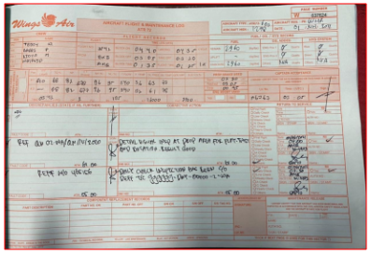
Below is AFML W 637624 record:

No record of capacitance check job

- RH Wing Fuel Leak
The repair of the screw with a layer of PRC sealant to prevent fuel leak during installation the fuel probe #1 (16 QT) on 01 June 2021 did not last long due to in fact that fuel leaking out from the fuel tank panel probe #1 (16 QT) was noticed during performing transit check at station Babo on 04 June 2021.
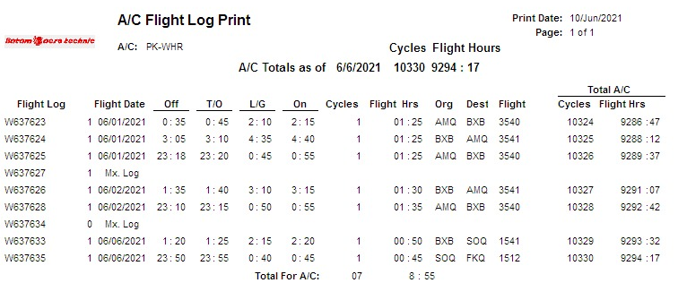
And based on the TRAX data flight log report, that the fuel leak which is occurred during transit check at station Babo (BXB) post flight IW-3544 : AMQ-BXB, on 04 June 2021 (AFML W 637631) , was the fifth flight (five flight after) since the repair of the screw with a layer of PRC sealant was conducted during daily inspection at station AMQ on 01 June 2021 (W 637624), evidence below:

- Dirty Dozen in Aviation Maintenance factor(s),

Interview to the Engineer in Charged have been conducted, to seek the possibility of contributed Dirty Dozen in Aviation Maintenance factor(s), with the result:
- Fatigue factor – not contributed
Based on the information from the engineer in charge, he is in good health, not in a state of fatigue. Likewise, based on their work schedule, the engineer in charge was just return from ron duty at station Alor (ARD) on the previous day. He arrived at Ambon (AMQ) from flight Alor (ARD) at 08:00 local time, and the fuel probe job was started on 17:00 local time, quite time to rest before conducting the job.

- Lack of knowledge factor – contributed.
Based on the interview, the task of Functional Test of the Fuel Quantity-Probe System is the first experience. In terms of competence, it is obtained that the engineer in charge has held AMEL and with Company Authorization since 2019 and has worked handling ATR tasks for about 6 years since 2015.

Meanwhile the understanding engineer in charge with the function of sealant was quesionable, since he intentionally uses PRC sealant as a way to repair loose screw without cross check with the reference is not allowed.

- Pressure factor - not contributed.
Based on the interview, the engineer admitted that the job of Functional Test of the Fuel Quantity-Probe System Task: ATR-A-28-42-70-01001-340A-A was performed at 17:00 local time during daily inspection maintenance, therefore there was quite time limit to accomplish the job.

- Stress factor - not contributed.
Based on the investigation, there is no indication that engineer on duty experienced stress during the that day of maintenance of Functional Test of the Fuel Quantity-Probe System Task: ATR-A-28-42-70-01001-340A-A. He was accompanied by one engineer avionic and two mechanics on duty during performing the job.

- Complacency factor - contributed.
Based on the job interview, the task of Functional Test of the Fuel Quantity-Probe System is the first experience. In terms of competence, it is obtained that the engineer in charge has held AMEL and with Company Authorization since 2019 and has worked handling ATR tasks for about 6 years since 2015. But the engineer
did not try to find out first whether the use of sealant to repair loose screw or fastener is allowed in accordance with existing procedures or report it to his supervisor or related unit and he continued to repair the screw/fastener by applying with a layer of the PRC sealant instead of replacing it with a new one.

- Lack of communication factor - contributed.
The engineer in charge did not report nor communicate with group leader/chief/MCC immediately, when he found a difficulty to refitted one loose screw of fuel probe #1 (16QT). The engineer made his own decision because he believed at the fuel did not leak after he repaired by sealant PRC.

- Distraction factor - not contributed
Based on the interview, at that time the engineer in charge was perfomed a single job of the task Functional Test of the Fuel Quantity-Probe System Task: ATR-A-28-42-70-01001-340A-A refer to the MCC instruction to continue trouble shooting DMI No. 007387: Fuel Unbalance (RH tank drop until 150 kg).

- Lack of awareness factor - contributed.
Based on the interview result, that the engineer in charge was fully involved in the task of Functional Test of the Fuel Quantity-Probe System. Meanwhile, the engineer has too much confidence to repair the loose screw/fastener by applying sealant without notifying with his supervisor/chief/MCC previously.

- Lack of procedures - not contributed
Based on the investigation, the ATR 72 - Structural Repair Manual procedure provides the necessary information to perform a temporary and/or permanent repair to stop a fuel leak caused by:
- damage of the structure,
- loose fasteners,
- incorrect installation of components,
- incorrect sealant application.
However, the engineer in charge did not study this procedure as the reference to take action for repairing loosing screw/fastener using sealant.

- Conclusion
Based on data and reference above, findings, sequence of events, root cause, and contributing factors are as follows:

- Findings
Findings are statement of all significant conditions, even or circumstances in the occurrence sequence. The findings are significant step in the occurrence sequence, but they are not always causal, or indicate deficiencies. Some findings point out the condition that pre-existed the occurrence sequence, but they are usually essential to the understanding of the occurrence, usually in chronological order.

In this occurrence, the BAT Safety Department identified several findings as follows:

- On 04 June 2021 aircraft PK-WHR with flight number IW-3544 route AMQ-BXB experienced RH Wing fuel leak during transit check at station Babo (BXB).
- The source of the fuel leak came from one screw on the RH Wing fuel tank panel probe #1 (16 QT) which improper tightened (it was repaired with a layer of PRC sealant).
- Previously, on 01 June 2021, the engineer in charge has received the instruction from MCC through What App message to continue trouble shooting DMI No. 007387: Fuel Unbalance (RH tank drop until 150 kg).
- The engineer admitted that during the fuel probe removal process, it was found that two of six screws on the fuel probe #1 were hard to be removed.

- During maintenance of installation RH wing fuel probe #1(16 QT), it was found one screw was still unable to be installed in place properly. The engineer applied a sealant of PRC to repair the screw in place properly.
- The usage of sealant PRC to repair the screw was questionable, especially on the critical system (example: fuel system, etc.) and invisible area during maintenance, since it was unable to be monitor properly, therefore the potential of failure was difficult to be avoided.
- The capacitance checks task MP ATR-A-28-42-70-01001-340A-A, did not documented accordingly (AFML record: AFML W 637624) due to the instruction was given through WA message instead of a formal Work Order
- The repair of one loose screw on the fuel probe #1 with sealant is also not reported or written in the turn over book report.
- The fuel leak which is occurred during transit check at station Babo (BXB) post flight IW-3544 : AMQ-BXB, on 04 June 2021 (AFML W 637631) , was the fifth flight (five flight after) since the repair of the screw with a layer of PRC sealant was conducted during daily inspection at station AMQ on 01 June 2021 (W 637624)

- Sequence of the events :
The sequence of events is defined as the order of events as they happen in an occurrence. Should think about what happens in the beginning, middle, and end of the occurrence to find the sequence of events.

In this occurrence, the BAT Safety Department identified the sequence of the events as follows:

RH Wing
Fuel Leak

Unable to be detected when the leak occurred and
undetected condition prior to the fuel leak

Found leak from comes from one improper screw position at
RH wing fuel probe #1 (16 QT)

Lack of monitor condition post screw repaired by sealant

The screw was repaired by sealant PRC

One screw of RH wing fuel probe #1 was unsecure condition

- Root Cause :
The root cause is defined as the factor causing a non-conformity and must be eliminated permanently through process improvement.

The root cause of the occurrence of fuel leak from RH wing tank was due to the unsecure condition of one loose screw during installation RH wing fuel probe #1 (16 QT) and then gradually lead the fuel leak and drop out from the RH fuel probe #1

- Contributing Factors :
The contributing factor is defined as something that helps cause a result.

In this occurrence, the BAT Safety Department identified the contributing factors lead to this event as follows:

- The improper action to repair the fastener by sealant PRC during installation RH fuel probe #1 (16 QT). The fastener shall be replaced by the new one instead of repaired by sealant.

- Poor communication and coordination during performing functional test of the fuel quantity probe system on the RH Wing ref task MP ATR-A-28-42-70-01001-340A-A, resulted that the the job was unable to be monitored and documented properly.

- The understanding engineer in charge with the function of sealant was quesionable, since he intentionally uses PRC sealant as a way to repair loose screw without cross check with the reference is not allowed.

- Procedure to repair fastener by sealant shall be avoided to prevent the same occurrence in the future. In this condition, to replace the fastener by new one is necessary, therefore the availability of supporting part is required to meet the maintenance need in the line.

- Safety Action
At the time of issuing this Report, BAT Safety Department had been informed of safety actions taken by the related parties resulting from this occurrence:
- BAT Safety started to conduct safety investigation related this issue once this event occurred on 4 June 2021.
- On 07 June 2021 - BAT Quality Department has issued Quality Report 026‐QLM‐VI‐2021 as the preliminary action to prevent the same occurrence from happening in the future.
- On 18 June 2021 - BAT Quality Assessor has conducted couching the engineer in charge in the term of quality aspect during performing maintenance and trouble shooting.
- On 18 June 2021 - BAT Safety has conducted interview with engineer in charge to complete the safety investigation in the term of human factor to seek the possibility of contributed Dirty Dozen in Aviation Maintenance factor(s).

- Recommendation
Based on the conclusion above, therefore Safety Department recommend that:

- Line Maintenance
Line Maintenance AMQ Manager/Area 9 (Korwil 9) Manager to immediate conduct briefing with stressing of the subject:
- To strictly follow procedure documentation during performing maintenance activities.

- To confirm to maintenance personnel not to continue the job if it is found the difficulty and ambiguity. Consult to the supervisor/MCC/specialist for clarification. Find the proper reference before continuing the job.

- To ensure that the job is accomplished accordingly, meet the requirements and free from risk/hazard

- Quality Department
Quality department shall immediate:
- To ensure the quality system process during performing maintenance meet the current existing procedure (discipline with documentation recording) by improving QC random check.

- To ensure the safety recommendation upon this case is implemented by related department accordingly.

- To insert this case to the engineer assessment material as the lesson learn.

- Schedule the related personnel for Human Factor and SMS re current training

- BAT Training Center
BAT training center to include this issue on Human Factor and SMS re current training material to be addressed the information to maintenance personnel.

Prepared by: |  | Presented by: |  |  |  |  | Accepted by:
Nurhaji  Investigator |  | Wiku Wrayang Irawan  General Manager |  |  |  |  | Agus Trisno Santoso  Director SSQ BAT
BT-SS-002/R0, Issued date 10 July 2019

